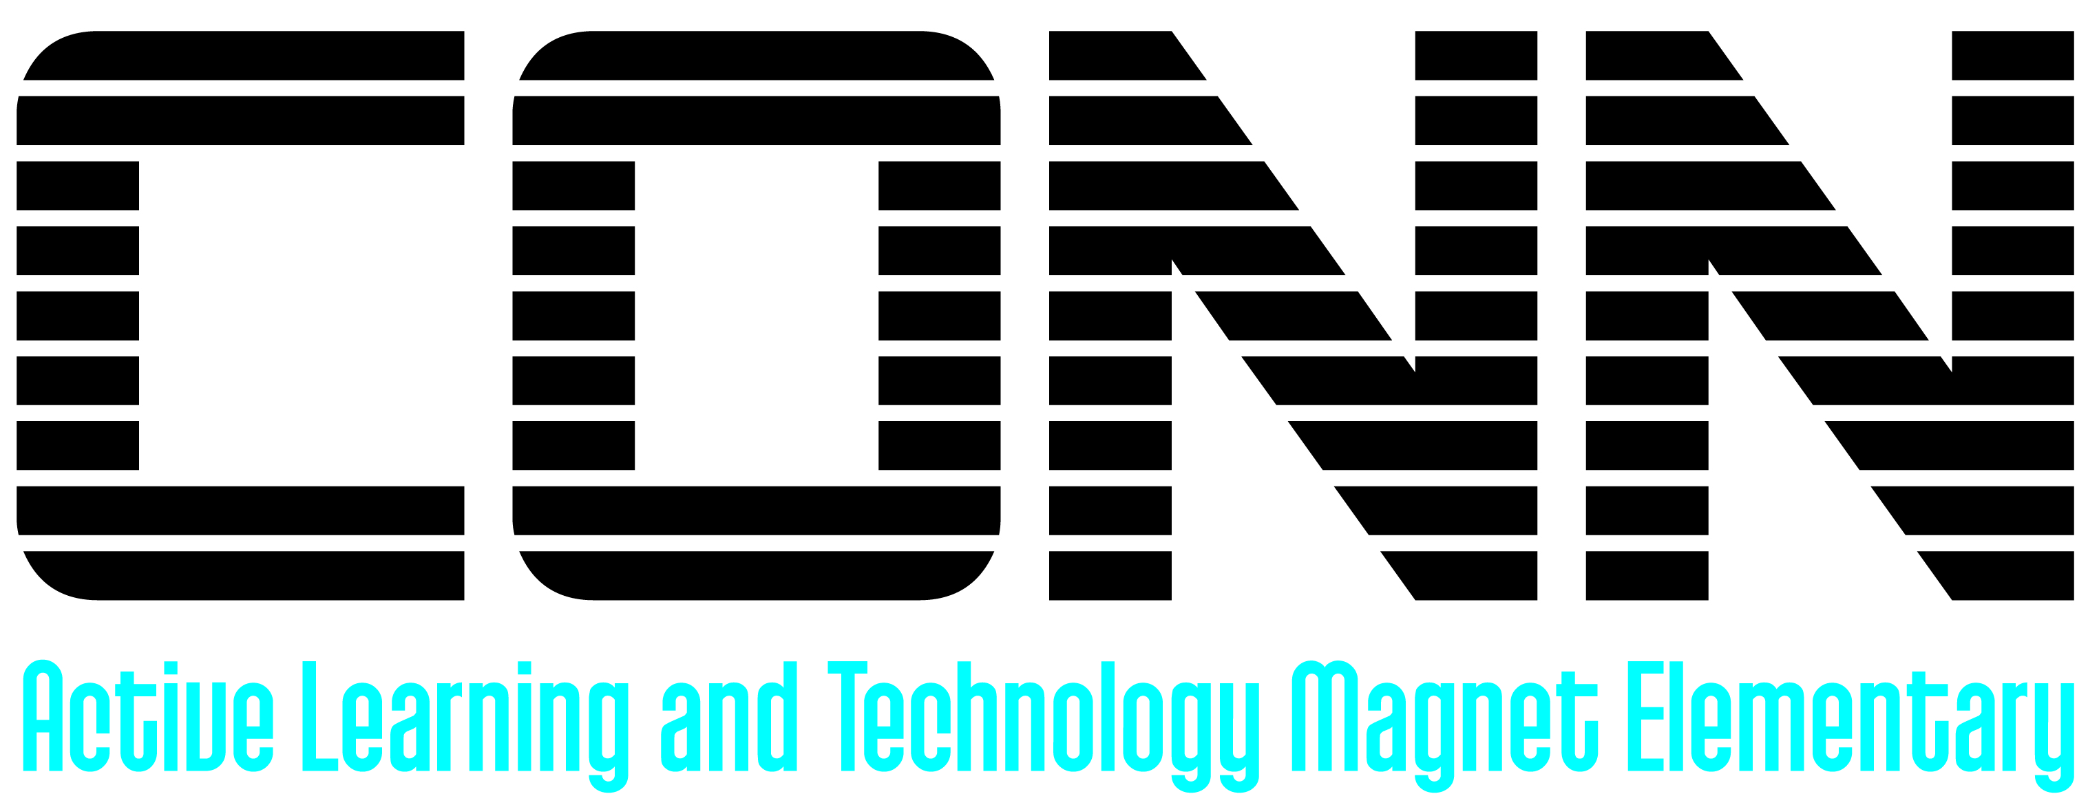 Parent Library Card Application

Name: ______________________________________
Student’s name: _____________________________
Student’s teacher: ___________________________
Mailing address:

Email: ____________________________________________
Phone: ____________________________________________
I agree to be responsible for material borrowed with this card.
I agree to pay for any lost or damaged materials and will return materials on time.
I understand that any materials not returned to Conn will be transferred to my student’s account at the end of the year.
Maximum check out: 5 books at a time.
Lending time: 2 weeks
Extended hours: Monday, 8:30 – 5:00
Parent signature ________________________________Date____________

